# Media Analysis - ChatGPT is the ‘Netscape moment’ for artificial intelligence’ _ Arab News

## Short Summary

The article is about ChatGPT being compared to Netscape s impact on the World Wide Web, as it is revolutionizing artificial intelligence through its conversational interface, large language models LLMs , and potential for creating value in various sectors like law, publishing, and consulting.

## Summary

1. ChatGPT, built on Large Language Models (LLMs), is a game-changer for artificial intelligence, similar to the impact Netscape had on the World Wide Web.  
2. LLMs can generate responses, summarize texts, and create large amounts of text content based on prompts, but they lack world knowledge, common sense, or the ability to reason.  
3. The future of AI includes the development of systems that resemble human thinking, including common sense, an understanding of the world, ethics, and reasoning abilities.  
4. AI adoption is crucial for addressing economic challenges such as productivity, labor costs, and demographic shifts, with Saudi Arabia well-positioned to leverage this technology, particularly in localizing and extending LLMs to regional languages and domains.

## Question 1

In the analyzed text, the metaphor that repeatedly appears in framing the public discussion about ChatGPT is that of a breakthrough or a revolutionary moment in artificial intelligence AI . The text refers to ChatGPT as the Netscape moment for AI, likening its impact to Netscape s influence on the popularization of the World Wide Web. Additionally, there are mentions of AI foundations being similar to web, mobile, and social platforms, emphasizing their potential role as a new platform for value creation in various industries. The text also uses metaphors like enriched and extended when discussing how models like ChatGPT can be developed further with specialized data and integrated into applications. Lastly, the text mentions that AI can serve as a productivity lever, suggesting that it could help economies become more efficient during challenging economic times.

## Question 2

The text discusses various perspectives and aspects of ChatGPT and large language models LLMs . Some of the topics being widely covered include their effectiveness in tasks such as question answering, text summarization, and content generation their potential applications in industries like law and consulting and their limitations, particularly their lack of world knowledge, common sense, and ability to reason. The text also mentions the impact of AI on productivity, workforce reduction due to automation, and its potential role in addressing demographic challenges, especially in developed countries with aging populations. On the other hand, aspects that seem to be ignored in this text include the social, ethical, and policy implications of widespread AI adoption, privacy concerns related to data used by these models, and the potential impact on jobs and employment structures. Additionally, while the text mentions the need for AI systems with common sense, an understanding of the world, ethics, and the ability to reason, it does not delve into how these capabilities might be developed or integrated into current AI models like ChatGPT.

## Question 3

The article does not mention any specific role for the Arabic world in terms of leveraging AI.

## Question 4

The article s final message highlights the rapid evolution of Large Language Models LLMs like ChatGPT, emphasizing their potential benefits in various fields while acknowledging their current limitations. It encourages entities in Saudi Arabia to explore AI technology for value creation, positioning the Kingdom as a leader in this domain and ensuring future economic sustainability and prosperity.

## Sentiment

The sentiment is 3.0

## Entities

Aramco, Disclaimer Views, exempli ed, Anthony Butler, AI Authority, Arab News, GPT, AI, the Saudi Data, IBM, ChatGPT, ANTHONY BUTLER

## Highlights

#7cc867#fb5b89#c885da

## Wordcloud for #7cc867 Highlights

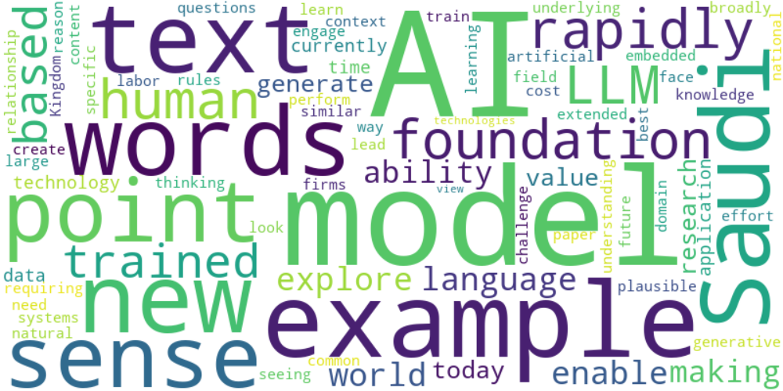

Top 10 words:

- AI: 13

- models: 8

- example: 6

- words: 5

- Saudi: 5

- text: 4

- point: 4

- sense: 4

- like: 4

- rapidly: 4

## Wordcloud for #fb5b89 Highlights

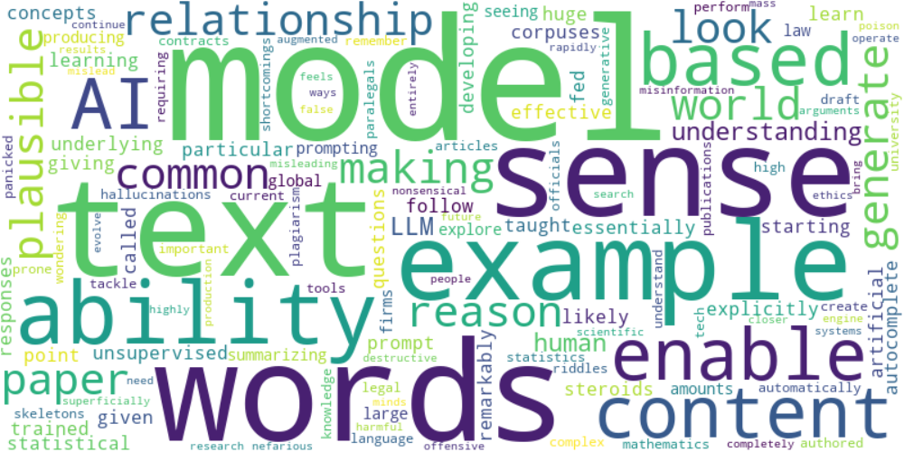

Top 10 words:

- models: 6

- words: 5

- text: 4

- sense: 4

- like: 3

- example: 3

- ability: 3

- model: 2

- content: 2

- based: 2

## Wordcloud for #c885da Highlights

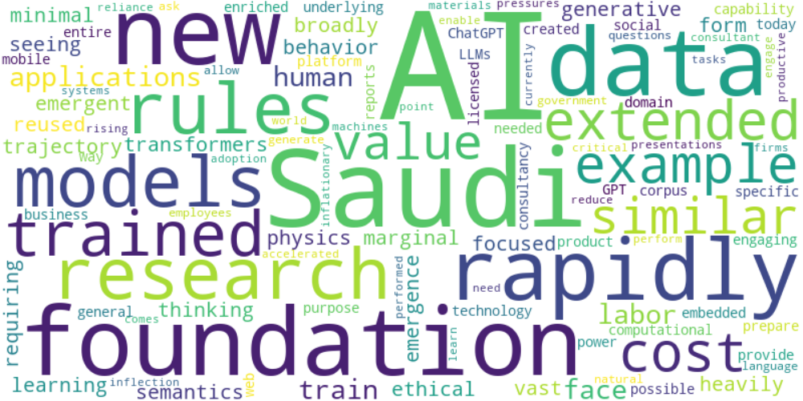

Top 10 words:

- AI: 9

- Saudi: 4

- new: 3

- rapidly: 3

- research: 2

- rules: 2

- foundation: 2

- trained: 2

- extended: 2

- example: 2